Madison AVID Graduation and College Admission Rates
AVID
Advancement Via Individual Determination

avid adj. (L. avidus, eager for knowledge)

AVID Facts
The AVID Parent

AVID parents encourage their students to achieve academically, participate in AVID parent and site team meetings, and maintain regular contact with the AVID teachers and coordinator.

The AVID Curriculum
The AVID curriculum, based on rigorous standards, was developed by middle and senior high school teachers in collaboration with college professors. It is driven by the WICOR method, which stands for writing, inquiry, collaboration, organization, and reading. AVID curriculum is used in AVID elective classes, in content-area classes in AVID schools, and even in schools where the AVID elective is not offered.
The AVID Tutor
Tutors are essential to the success of the AVID elective class, where they facilitate student access to rigorous curriculum. As students from colleges and universities, tutors receive formal training and also serve as role models. AVID students who continue their education in college often return to the program as tutors.

Madison AVID Class Graduating | HS Graduate | 4 yr. College  Acceptance | Attending 2 year or 4 year college
2017 | 100% | 94.44 | 100%
2016 | 100% | 100% | 100%
2015 | 100% | 100% | 100%
2014 | 100% | 96.4% | 100%
2013 | 100% | 95% | 100%
2012 | 100% | 100% | 100%
2011 | 100% | 100% | 100%
2010 | 95% | 100% | 100%
2009 | 100% | 90.9% | 100%
Totals for 9 years of  AVID grads | 99.44% | 97.4% | 100%

Phone: 503-916-5220
Web site: http://www.pps.k12.or.us/schools/madison/

Madison High School

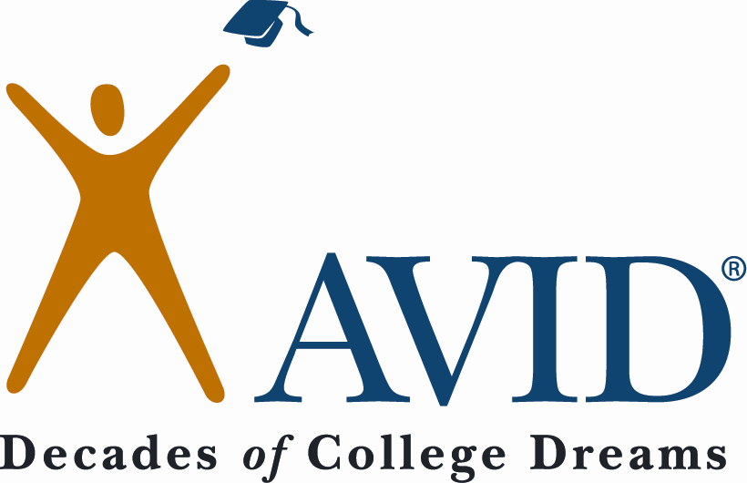

What is AVID?
AVID students are students in the middle, capable of completing a college preparatory path with support. These students often are not realizing their full potential academically. In the identification process a number of criteria are considered, including:

- Essential Skills Scores
- 2.0 – 3.5 GPA
- Attendance
- Desire and Determination
- First in the Family to Attend College
- Historically Underrepresented in 4-year colleges/universities
- Economically Disadvantaged
- Other Special Circumstances
AVID Activities

• Writing, Inquiry, Collaboration, Organization, Reading (WICOR) methodologies are the basis for curriculum instruction

• Students participate in field trips to colleges/universities

• College students act as role models and facilitate academic discussion in regularly scheduled tutorial groups

• Students develop academic and social skills for success in all subject areas

• Guest speakers provide motivation and college and professional career information

• AVID students participate in extracurricular and community events

Who is an AVID Student?
AVID is an academic, regularly scheduled elective class, during the school day, based on writing as a tool of learning, the inquiry method, and collaborative grouping. The three main components of the program are:
- Academic instruction
- Tutorial support
- Motivational activities

AVID
Mission Statement

The mission of AVID is to close the achievement gap by preparing all students for college readiness and success in a global society. AVID students will:

- Will succeed in rigorous curriculum

- Will complete a rigorous college preparatory path

- Will enter mainstream activities of the school

- Will increase their enrollment in four-year colleges

- Will become educated and responsible participants and leaders in a democratic society

Madison High School
2735 NE 82nd AVE
Portland, Or
97220

503-916-5220
Contact Information

Roberta Cooper
AVID Co-Coordinator
coop@pps.net
503-916-5220 X 79270

Santha Cassell
Instructional Coach
AVID Co-Coordinator
scassell@pps.net
503-916-5220 X 79382

